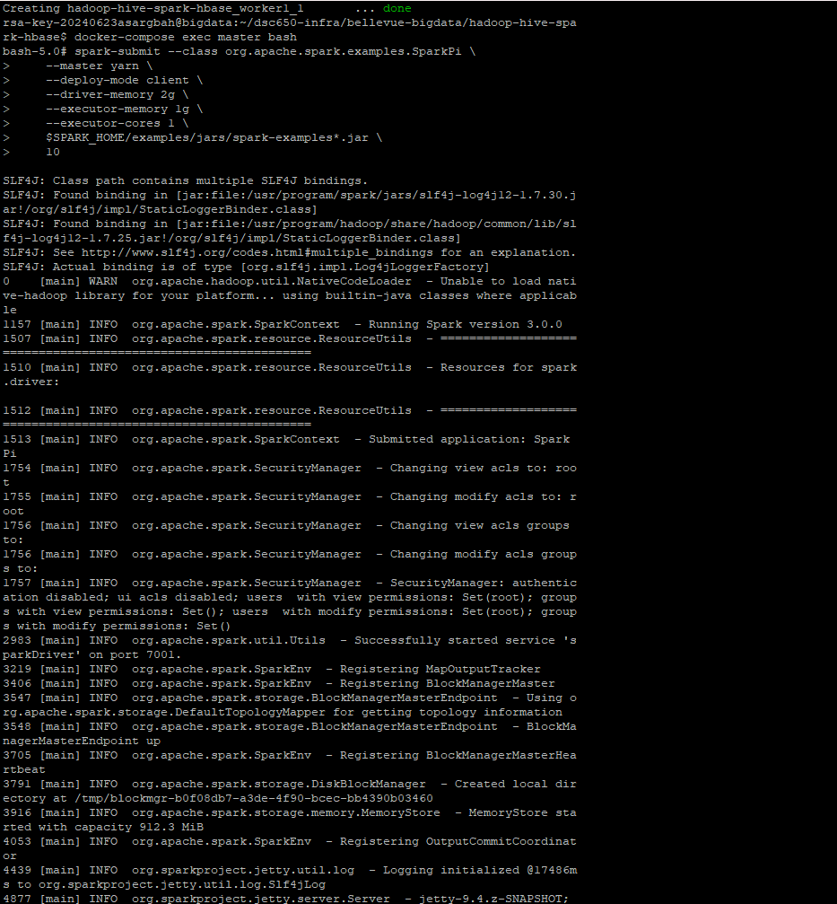

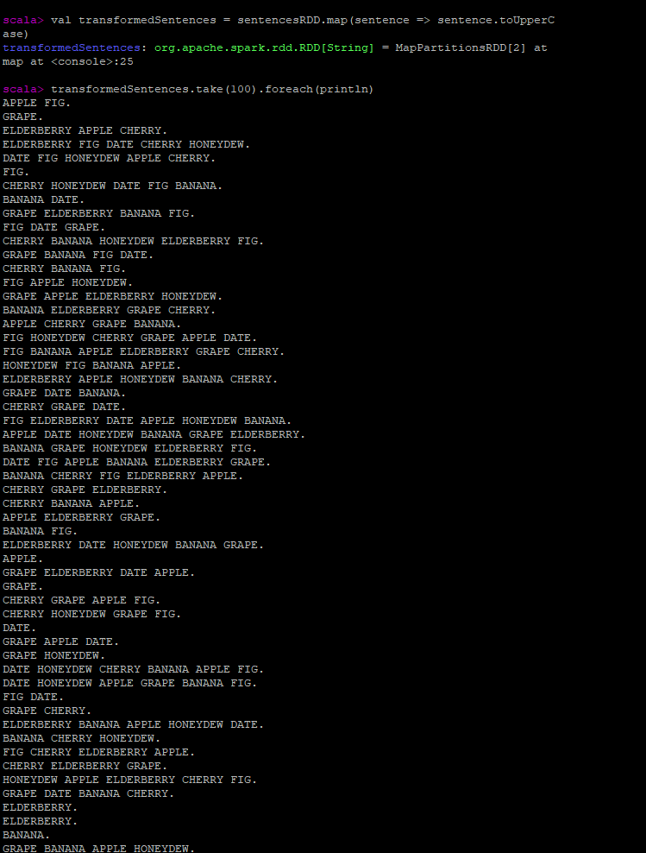

For this week we began working with Apache Spark, using scala and PySpark. I began by initializing the directory to route the assignment to the Bellevue-bigdata folder. After I did that, and then set up the docker, I ran the first example with PySpark, which you can see in my first screenshot. From there, in the second screenshot, you can see that I started the scala shell, and then began generating and printing random numbers in the shell, in that screenshot you can see the numbers generated. Then I transformed my sentence within the scala shell, for my custom transformation I chose to make each first letter an upper-case letter.